Lecture 8



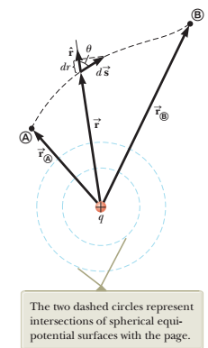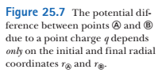

We are going to compute a potential difference between points A and B for electric field created by a point charge q (see Figure 25.7). The general expression for ΔV is:



The Electric field of a point charge:



where r^ is a radial unit vector

Hence,  is:



and $\hat{r} ∙\hat{ds}=ds∙cosθ$ which is projection of the displacement vector $\vec{ds}$ onto $\hat{ r}$.

hence, $\vec{E} ∙\vec{ds}=k\frac{q}{r^{2}}dr$

So, the integral above becomes:

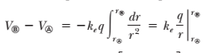



Eqn 25.10 shows that the electric force acting on a test charge q0:

is *conservative*: it means that the path integral of this force between points A and B depends only on rA and rB – but on a specific path

Hence, the electric field of a point charge is a *conservative field*

Usually V is defined as zero at $r = ∞$

Hence, a potential of a point charge q at distance r is:

$V\left(r\right)=k\frac{q}{r}$**(25.11)**

The superposition principle for electric forces --> the superposition principle for potentials.

The total electric potential at some point P due to several point charges is the sum of the potentials due to the individual  
charges.



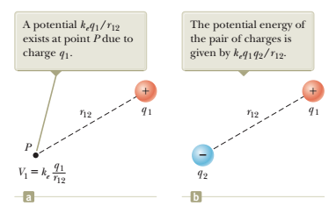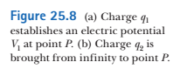

Now imagine that an external agent brings a charge *q*2 from infinity to point *P*. The agent does work that is equal to potential energy of charge q2 in the electric field formed by charge 1:



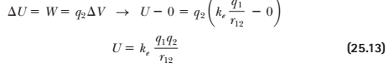

It is accepted that potential energy of two charges with distance = $∞$ is zero.

If the charges are of the same sign, then *U* is positive

For many charges? Algebraic sum over pairs

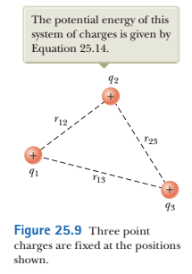

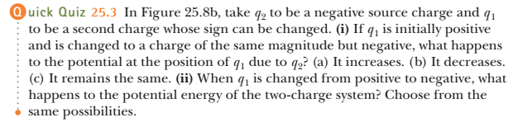



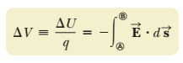

for small change of potential (and small displacement):



Hence, for only one x-component:







Hence, Electric field is a measure of rate of change of potential with x

E is a - slope of V(x) function

On an equipotential surface, dV = 0

and dV = -Edx = 0 , hence E is perpendicular to the equipotential surface

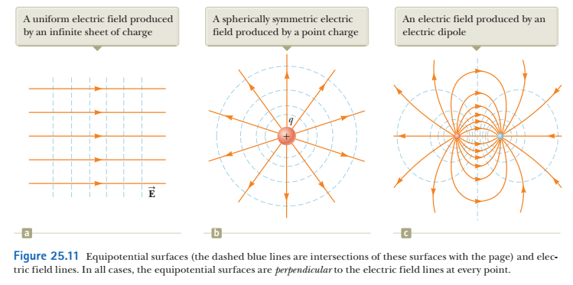

If the charge distribution creating an electric field has spherical symmetry such that the volume charge density depends only on the radial distance *r*, the electric field is radial. Then



and





For example, for a point charge:



Taking a derivative,



As we can see, V depends only on r. The equipotential surfaces are spheres

General case: V=V(x,y,z), and





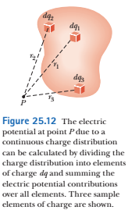

From Equation 25.11, the electric potential *dV* at some point *P* due to the charge element *dq* is



To obtain the total potential at point *P*, we integrate Equation 25.19 to include contributions from all elements of the charge distribution

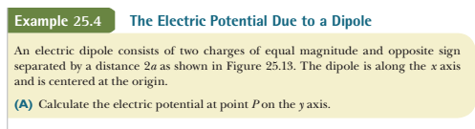

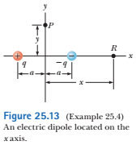









in the solution B) we ignore a2 in the denominator:



